1. 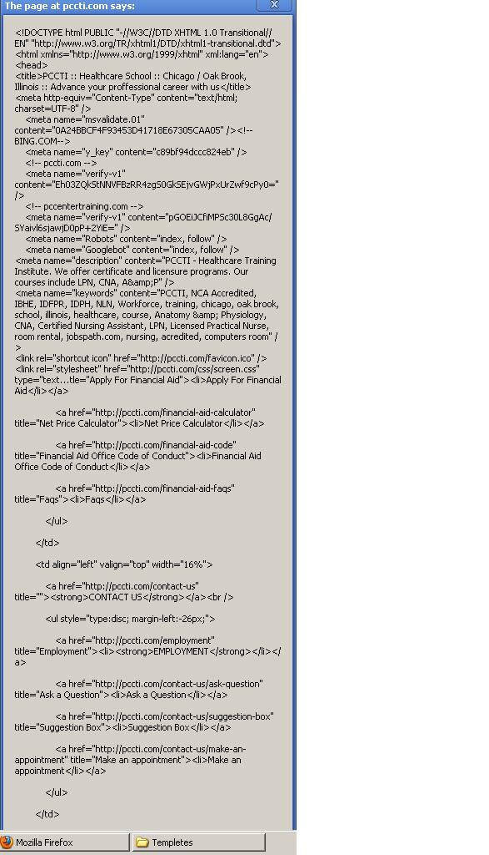After log in 🡪 after putting some code 🡪 it give this box of message .
2. After closing is coding box, it shows this screen which looks good.

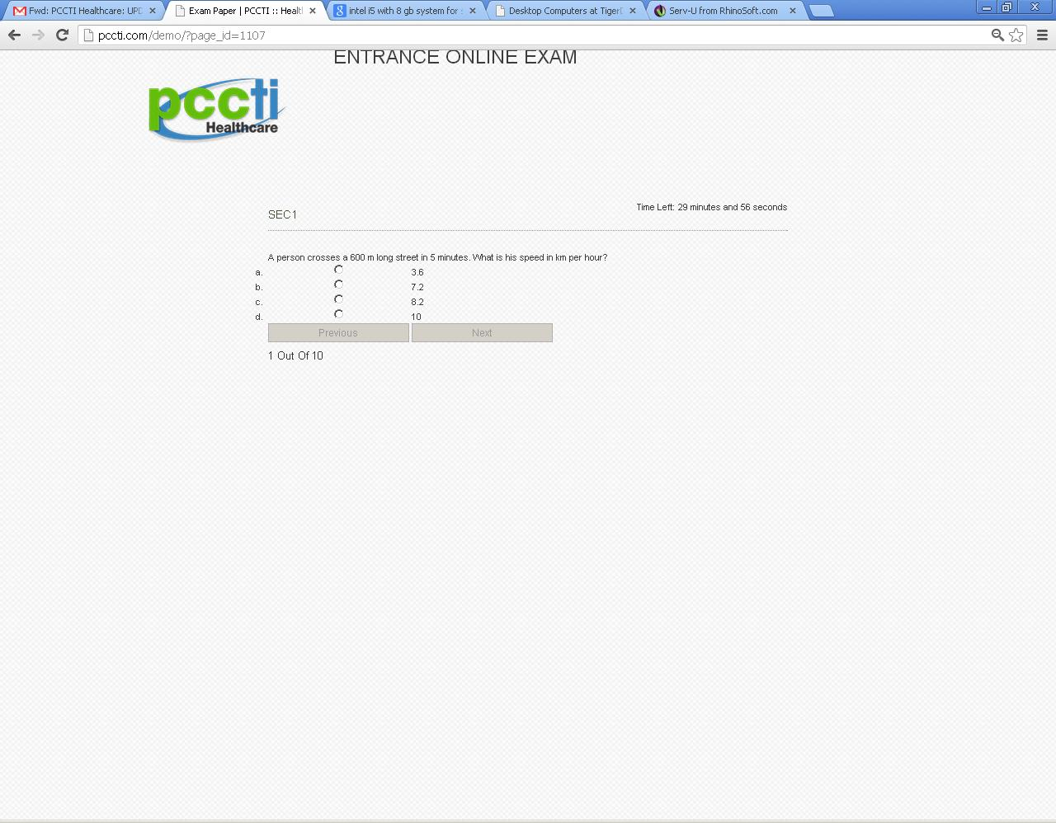

1. 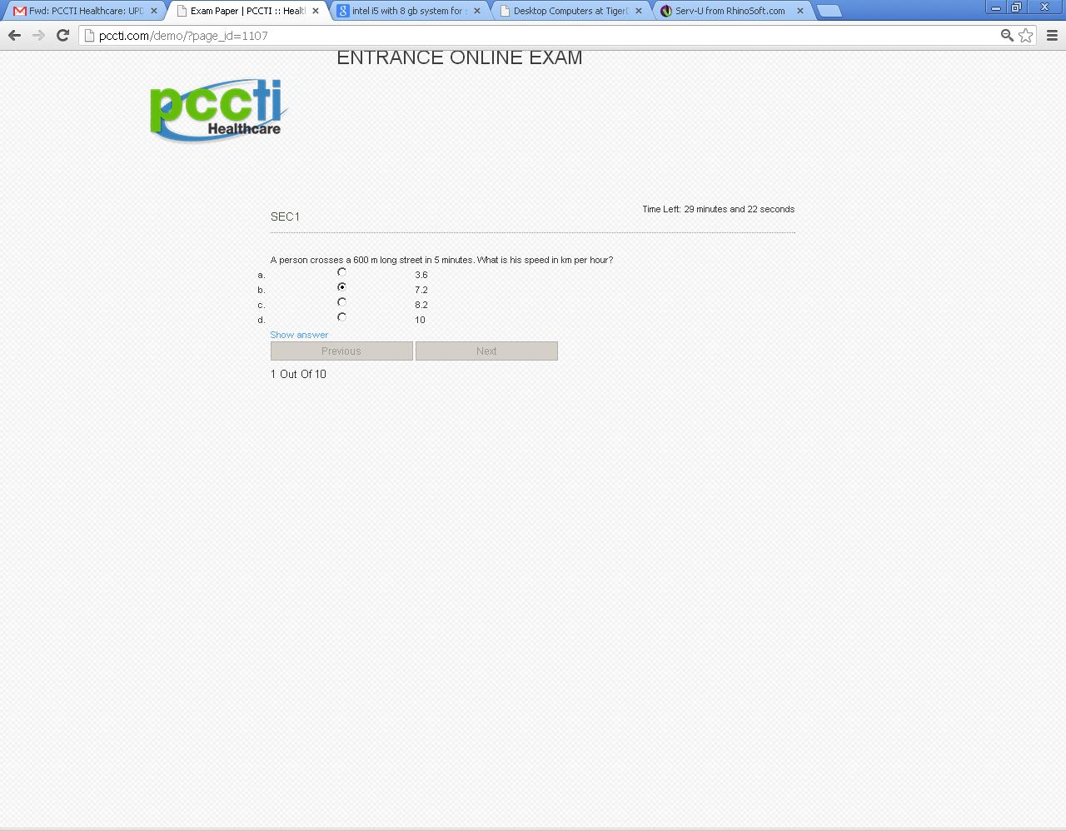When we select the answer its show the show answer tab. Right after when we select the tab.
2. 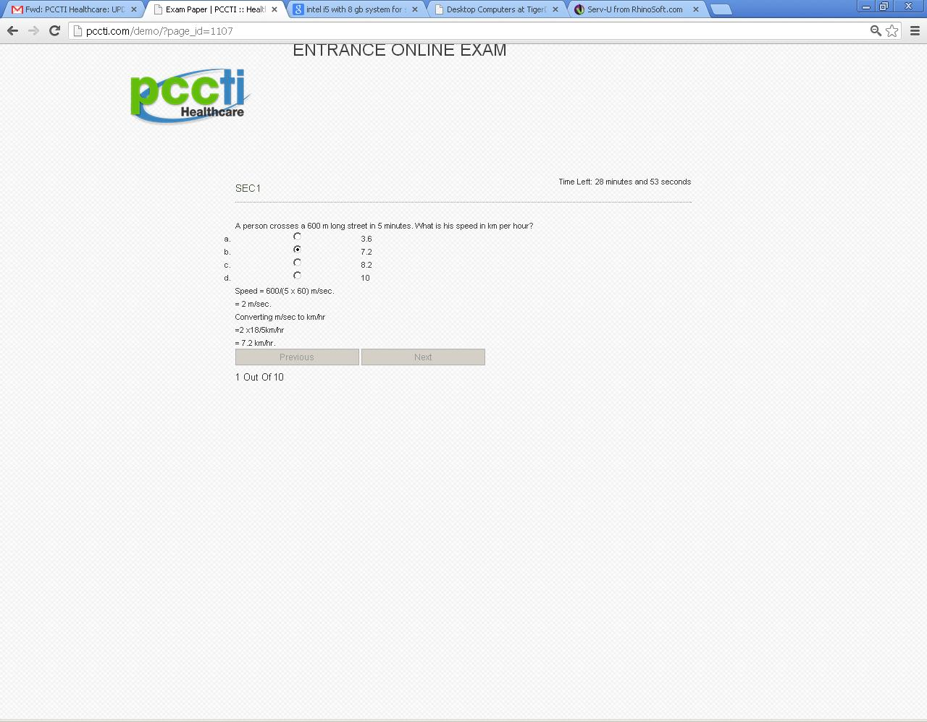When we click on the show answer it gives the answer, which it doesn’t suppose to show like this. Please remove the show answer from there.
3. In the end it show this screen,

